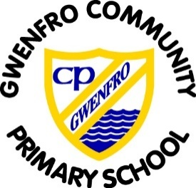

**Pupil Development Grant Statement 2025-2026**

The purpose of the Pupil Development Grant is to improve the educational attainment of pupils from low income families who are entitled to free school meals (eFSM). School are expected to maximise the use of this funding by introducing sustainable strategies which will lead to improved outcomes for these pupils.

For 2025-2026, we have been allocated £196,650 PDG funding.

Our focus when planning expenditure is based on:

* Developing high quality teaching and learning
* Developing community focus schools
* Developing early childhood play, leaning and care
* Developing high aspirations supported by strong relationships
* Develop health and well-being
* Leadership
* Developing our approach to Curriculum for Wales
* Support pupils’ social and emotional well-being
* Improving physical development
* Developing speech and language and communication skills
* Improving the educational attainment of CLA pupils

Gwenfro School has a comprehensive plan, agreed and monitored by Governors and the LA, to promote high expectations, attainment and progress, and to remove barriers to learning for pupils entitled to this funding.

Strategies funded by this grant are:

* Improve pupil access and use of digital platforms to support Learning for eFSM pupils
* Improve class support for pupils who are eFSM
* Continue to develop provision to support improved learning opportunities in line with Curriculum for Wales
* To continue to support and encourage reading for pleasure
* To continue to develop the role of the Family Engagement Officer in supporting pupils and their families
* To provide financial support families to access curriculum and well-being enrichment
* Improve pupil’s emotional wellbeing
* To continue to develop provision to support self-regulation and emotional well-being of pupils