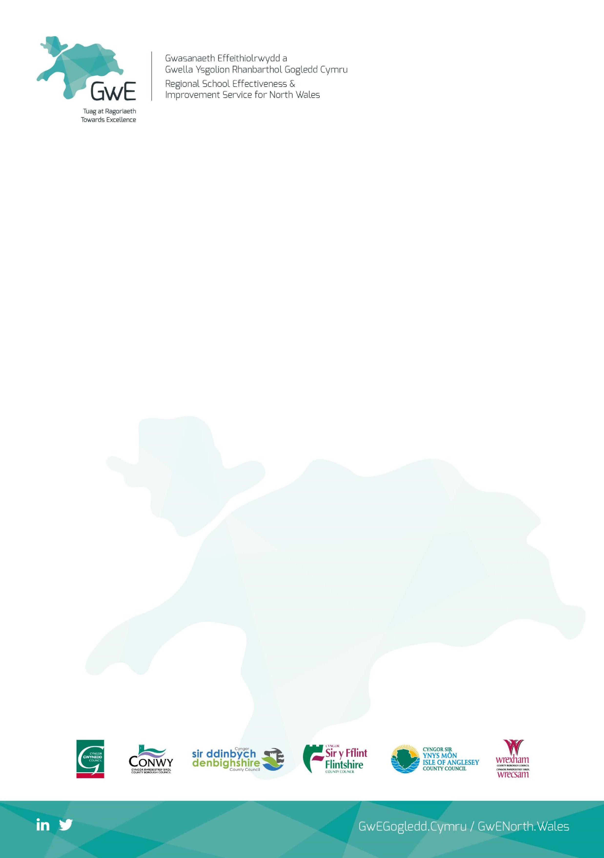

**Gwenfro Community Primary**

**Schools’ Pupil Deprivation Grant Statement**

The purpose of the Pupil Deprivation Grant is to improve the educational

attainment of pupils from low income families and who are entitled to free

school meals (eFSM). Schools are expected to maximise the use of this funding by

introducing sustainable str

ategies which will quickly lead to improved outcomes

for pupils entitled to free school meals.

As a school, we want to learn from the best practice in Wales and beyond by:

1

. planning interventions that focus on improving the attainment of pupils from

deprived backgrounds, regularly monitoring pupils’ progress and evaluating the

impact of the intervention.

2

. integrating plans for the effective use of the PDG into the School Development

Plan, basing our practice on sound evidence and including them as

part of a

whole school strategy.

3

. balancing whole school strategies with targeted interventions to ensure that

all learners entitled to free school meals benefit as individuals, whilst the whole

school also develops its ability to support every learner

to achieve their full

potential.

In 2018-

19

Gwenfro School

were allocated a total Pupil Deprivation Grant of

£

153,300.00

Gwenfro School has a comprehensive plan, agreed and monitored by GwE and

Wrexham Local Authority, to promote high expectations at

tainment and

progress and to

remove barriers to learning for pupils entitled to this funding.

We have used the funding available to:

•

Improve school attendance and punctuality of pupils entitled to FSM

•

Improve pupil’s emotional wellbeing through in school counselling and peer mentoring programmes.

-

•

Well-Being Manager release to support vulnerable groups

•

Improve class support given for pupils who are eFSM

•

Improve outdoor

•

Provide music tuition and support for Creative Development across the curriculum

.