BUG CLUB



Primary

Summer 2017

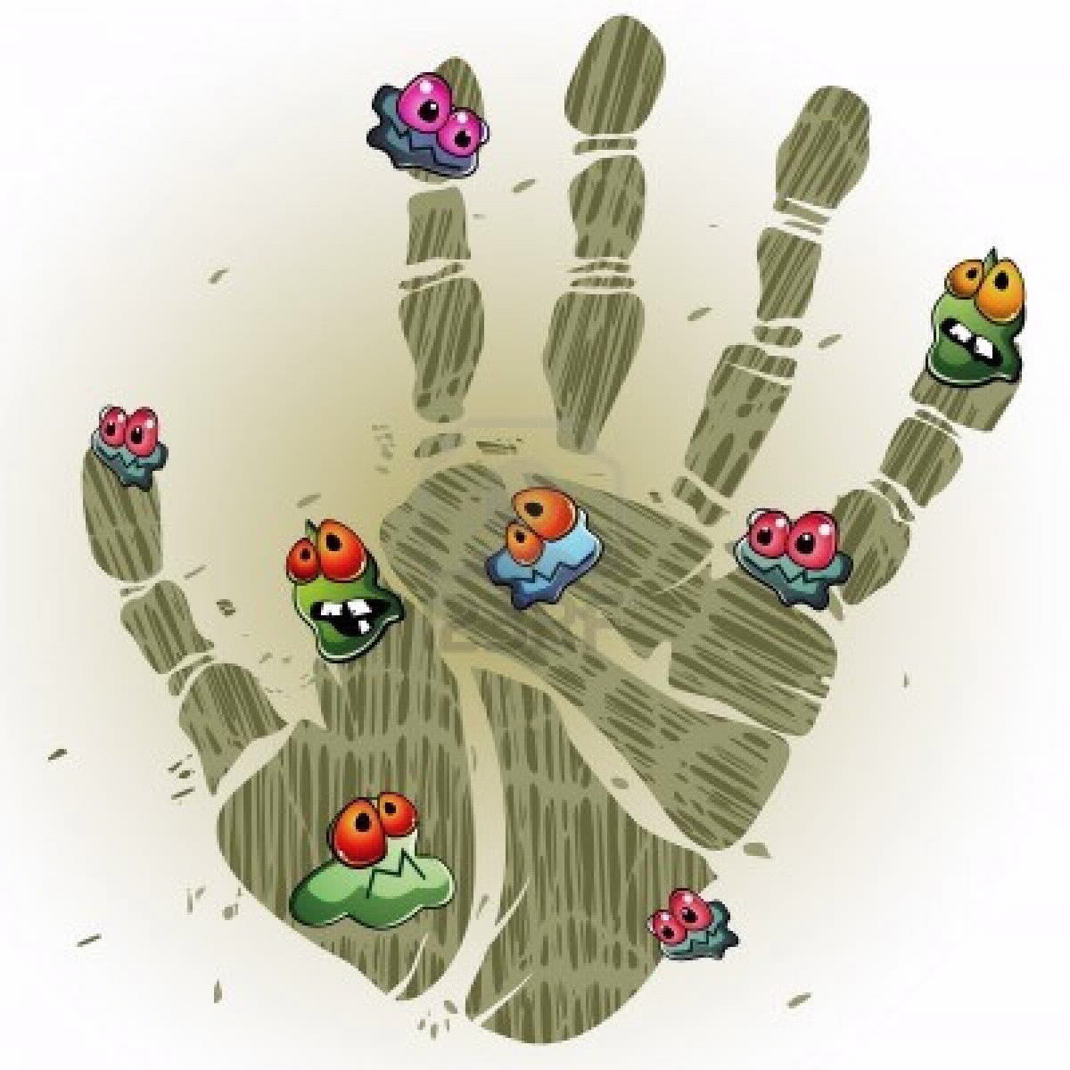



**At last, it’s the summer holidays!**

But, whether you are going abroad or having a staycation, going to the beach or playing in the garden, keep the whole family safe and well this summer.

[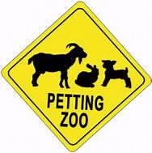](http://www.bing.com/images/search?view=detailV2&ccid=3VHo/sEu&id=254A9E4382310CE578851FFC3EE150FCA35847EE&q=petting+farms+cartoon&simid=608001601912113735&selectedIndex=19)

**Petting Farms/ Zoos**

Petting farms and zoos are great places to keep little ones entertained, but some animals can pass illnesses on to people and make them very unwell. Even animals that look clean and healthy will carry some bugs.

But it’s really easy to stay healthy!

* **Everyone needs to wash their hands with soap and water, not gels or wipes.**
* - after touching the animals and their pens
* - before eating or drinking
* - when you leave

• **Clean shoes and pushchair wheels** at the end of your visit. Wash your hands with soap and water after the cleaning

•**Everyone should avoid touching their faces or putting fingers in mouths** while at the farm

• **Don’t let children to get too close to, or kiss, the animals**

* **Don’t let children use dummies or soothers**
* **If anything that a child puts in their mouth is dropped on the floor at the farm, don’t give it back to them until thoroughly cleaned**



**Travel Vaccinations**

Wherever you are holidaying this summer, add “check everyone’s jabs are up to date” to your pre-holiday checklist!

If you are going abroad, you may need some extra vaccinations to keep you, and your family, safe.

If you’re not sure what you need, talk to your GP or practice nurse or go to:

<http://travelhealthpro.org.uk/countries>

**Stay safe in the sun**

On sunny days, at home or away, it can take just 15 minutes for the sun to burn, and damage, yours and your child’s skin. To avoid it;

* **Use sunscreen or sun block of at least SPF 15.** Put it on before you go outside and top it up during the day, even if the bottle says it only needs to be applied once.
* **Cover up with loose fitting clothes**
* **Wear a hat and sunglasses**. Baseball caps do not protect the ears and neck
* **Drink plenty of water**
* **Stay in the shade** and avoid the sun between 12pm and 3pm (the hottest part of the day).

Further information and advice is available on Public Health Wales website at <http://howis.wales.nhs.uk/sitesplus/888/home>

Or your local health protection team on 0300 00 30032.

**Follow us on**

[](http://www.bing.com/images/search?view=detailV2&ccid=tkezL3Y1&id=A041EFA8C0A5041B92D4BF14AF5AABC202037DF1&thid=OIP.tkezL3Y1TkpZM3IxjGfpkwD6D6&q=facebook+icon&simid=608014869313028228&selectedIndex=0&qpvt=facebook+icon)[](http://www.bing.com/images/search?view=detailV2&ccid=8I2SVUbV&id=3B76DDF414AB67E449B77DD31E2304D6AE65134B&thid=OIP.8I2SVUbVYzuGe8XBWr7MkgEsEs&q=twitter+logo&simid=608014809187159006&selectedIndex=7)

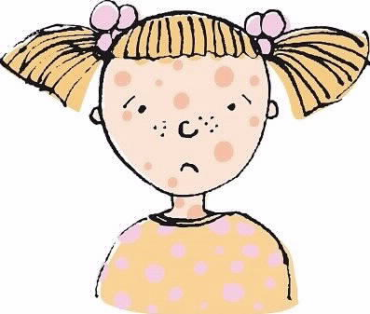

**Measles**

There are currently measles outbreaks in many parts of the world, including Europe and the UK.

Just like other childhood illnesses, people with measles are infectious well before they are ill. Measles spreads easily from person to person, especially where lots of people are together, like holiday clubs, play groups, soft play, shopping centres or parties.

To protect against measles, your child needs to have had 2 doses of MMR vaccine; one at 12 to 13 months old, and the 2nd at 3 years 4 months old. You can check with your GP if your child is up to date.

Measles symptoms include high temperature, cough, runny nose, red eyes (conjunctivitis), and a distinctive red rash. Children with measles are very, very unwell.

If you think your child has measles, telephone your GP or GP out-of-hours service to arrange an appointment. **DO NOT** go to the surgery or an A&E department without calling ahead to avoid passing measles on to other people.

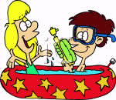

**Fun-time sun-time safety**

Spending all day sitting in the paddling pool in the back garden is what summer holidays were made for. Most people love the water. But, when your kids get out, who might be getting in? The little girl from next door? Or the little boy from down the road? Or might it be your little ones who sneak back when they think no one is looking? But what begins just as splashing can have serious consequences. It only takes a tiny amount of water for a small child to drown – the water just needs to be able to cover their noses. So, make sure that children in the pool are always supervised by an adult; this means being in the garden, within arms reach, and sitting up and watching, not in the kitchen or laying down, eyes closed. And make sure that the pool is emptied before being left.

Of course, there is another good reason for emptying the pool. What is nice, clean, cold water at the start of the day soon warms up and becomes more inviting. But as the day goes on, more sun screen is washed off bodies and into the pool, dirt from the soles of feet is added to it and someone has probably peed in it. In the warmer water, bugs and bacteria soon multiply. After three days, what was water is now a bug infested chemical soup. So, to avoid tummy upsets, rashes and itching, don’t use the same water for more than one day.